**Promoted for and on behalf of Cycling Time Trials under their rules and regulations**

**by**



## Start sheet

## For the

## Bigfoot CC Open 25 Mile Time Trial

## *Course - Q25/8 Challock – Canterbury – Ashford – Chilham*

## *Sunday the 24th May 2015 – 06:30 start*

**HQ - Challock Village Hall, Blind Lane, Challock, Kent TN25 4AU**

**COURSE DETAILS for Q25/8**: START on A252 East of Molash at corner post of Northdown House at entrance to Shottenden Lane. (TR032521) Proceed east on A252 and A28 to Milton Manor RAB Thanington (6.726 miles). TURN and retrace on A28 via Chilham fork where bear (EXTREME CARE) left to Spearpoint Corner RAB (17.126 miles). Retrace to Chilham fork where left to rejoin A252. Proceed westwards to FINISH approx 290 yards past Chilham Castle Keep entrance (TQ063535).

In the interests of your own safety, Cycling Time Trials and the event promoters strongly advise you to wear a HARD SHELL HELMET that meets an internationally accepted safety standard. Juniors and juveniles MUST wear such headgear.

Please respect the residents Sunday morning, keep noise to a minimum and note that the use of turbo trainers or rollers in the headquarters parking area or on adjacent roads is STRICTLY PROHIBITED. Failure to comply with this restriction could result in disqualification.

Timekeepers: Paul Mepham (V.C. Elan) & Christine Burrows (Thanet RC)

Event Secs : Andrew Ferry, 12 Meadway, Hildenborough, Kent, TN11 9HA

Tel: 07974205887 / Email: [andy.ferry@virginmedia.com](mailto:andy.ferry@virginmedia.com)

Rachael Haley, 15 Mons Way, Bromley, Kent, BR2 8EX

[Tel: 07402777818](mailto:Tel:%2007402777818) / Email: [rehaley@gmail.com](mailto:rehaley@gmail.com)

Notes to riders

* EVENT HQ: Challock Village Hall, Blind Lane, Challock, Kent TN25 4AU. Please respect the local residents. Sundays mean different things to different people. No shouting in the car park, music etc. Please keep noise levels to a minimum and park with consideration. If parking elsewhere please do not obstruct driveways or inconvenience the neighbourhood. Remove racing shoes before entering the hall.
* Numbers will be at the HQ and issued when signing in. Your number can be exchanged for a drink after event. Your number should be centrally positioned below the waist so as to be clearly visible from the rear when in the normal riding position.
* No parking at the Start and Finish (Except officials). The start is approx. 2 miles from the HQ. Please familiarize yourself with the start location and allow sufficient time to get there.
* Do not warm up on the course once the event has commenced and there must be no U turns within sight of the Timekeepers. Whilst competing riders must ensure they adhere to the Highway Regulations and CTT Rules and Regulations.
* Riders should familiarise themselves with the CTT rules and regulations at: <http://www.cyclingtimetrials.org.uk/Information/Procedure/Regulations/tabid/79/Default.aspx>
* Keep your head UP and have a safe and enjoyable ride ☺

**Prize List**



**Starting Order**

|  |  |  |  |  |  |  |
| --- | --- | --- | --- | --- | --- | --- |
| No | **Name** | **Club** | **Cat** | **LTS** | | **start** |
| 14 | Rachael Haley | Bigfoot CC | LV52 | 01:05:37 | | 06:44 |
| 15 | Rob Milnes | Thanet RC | 36 | 01:01:13 | | 06:45 |
| 16 | Dennis Montgomery | Bigfoot CC | V59 |  | | 06:46 |
| 17 | Serge Bouschet | Dulwich Paragon CC | V42 | 01:00:36 | | 06:47 |
| 18 | Andy Burrows | Thanet RC | V72 | 01:05:05 | | 06:48 |
| 19 | Alex Beaton | Bigfoot CC | V52 |  | | 06:49 |
| 20 | Mark Hill | VeloRefined Aerosmiths | V47 | 00:54:27 | | 06:50 |
| 21 | Benjamin Allen | Dulwich Paragon CC | 39 |  | | 06:51 |
| 22 | Danny Frost | Folkestone Velo Club - SCU | V52 | 01:02:42 | | 06:52 |
| 23 | Graham Strugnell | Kassei CC (Teknofuel) | V67 | 01:09:09 | | 06:53 |
| 24 | James Andrew | Gravesend CC | V41 |  | | 06:54 |
| 25 | Barry Stewart | Bigfoot CC | 33 | 00:58:12 | 06:55 | |
| 26 | Sam Bennett | 7 Oaks Triathlon Club | V42 |  | 06:56 | |
| 27 | Michael Sanders | Dulwich Paragon CC | 39 | 01:04:51 | 06:57 | |
| 28 | Jamie Durmush | Panagua.CC | 23 |  | 06:58 | |
| 29 | Martin Doone | Bigfoot CC | V43 |  | 06:59 | |
| 30 | Paul Smith | VeloRefined Aerosmiths | V43 | 00:54:22 | 07:00 | |
| 31 | Kelvin Hatch | Sydenham Wheelers | 27 | 00:57:09 | 07:01 | |
| 32 | Ian Turner | Southborough & Dist. Whs | V66 | 01:02:47 | 07:02 | |
| 33 | Mick Claydon | Ashford Whs | V47 | 01:05:14 | 07:03 | |
| 34 | David Lobley | 7 Oaks Triathlon Club | V50 | 01:08:34 | 07:04 | |
| 35 | Simon Henderson | Thanet RC | V52 | 00:57:08 | 07:05 | |
| 36 | Dominic Campbell | Medway Velo Club | 24 | 00:59:59 | 07:06 | |
| 37 | Andy Macpherson | VC Deal | V48 | 01:04:23 | 07:07 | |
| 38 | Ian Stephens | Medway Velo Club | V49 |  | 07:08 | |
| 39 | Lee Carpenter | Bigfoot CC | V53 |  | 07:09 | |
| 40 | Julian Bray | Dulwich Paragon CC | V51 | 00:54:08 | 07:10 | |
| 41 | Sam Day | CS Grupetto | V41 | 00:57:49 | 07:11 | |
| 42 | Don Curtin | VTTA Kent | V45 | 01:02:21 | 07:12 | |
| 43 | Helen Mckay | Les Filles Racing Team | L37 | 01:08:32 | 07:13 | |
| 44 | Ian Smith | Bigfoot CC | 38 |  | 07:14 | |
| 45 | Martin Foord | Abellio - SFA Racing Team | V52 | 00:57:03 | 07:15 | |
| 46 | David Haggart | De Laune CC | V54 | 01:01:50 | 07:16 | |
| 47 | James Dickson | Thanet RC | V50 | 01:03:52 | 07:17 | |
| 48 | Luke Nunn | Bigfoot CC | 21 |  | 07:18 | |
| 49 | Oliver Dickson | Thanet RC | J16 | 01:04:18 | 07:19 | |
| 50 | Wayne Van Ry | Bigfoot - SCU | V43 | 00:53:40 | 07:20 | |
| 51 | Mark Doxey | Abellio - SFA Racing Team | V46 | 00:57:48 | 07:21 | |
| 52 | Jayne Wadsworth | De Laune CC | LV44 | 01:03:39 | 07:22 | |
| 53 | Keeley Chalk | PMR @ Toachim House | LV45 | 01:06:41 | 07:23 | |
| 54 | Richard Bayfield | London Phoenix CC | V46 |  | 07:24 | |
| 55 | Christopher Bedson | Dulwich Paragon CC | V35 | 00:57:00 | 07:25 | |
| 56 | Stephen Avery | Bigfoot CC | V56 | 00:59:16 | 07:26 | |
| 57 | Katie Crowe | Dulwich Paragon CC | L39 | 01:04:01 | 07:27 | |
| 58 | Rebecca Wilson | Rye & District Wheelers CC | LV50 | 01:11:42 | 07:28 | |
| 59 | Ivor Hewitt | Oxted Cycle Club | V43 |  | 07:29 | |
| 60 | Kevin Grimshaw | Bigfoot CC | V48 | 00:53:36 | 07:30 | |
| 61 | Andrew Macey | PMR @ Toachim House | V53 | 00:57:45 | 07:31 | |
| 62 | Mark Amon | Rye & District Wheelers CC | V50 | 01:01:22 | 07:32 | |
| 63 | Matthew Stammers | Ashford Whs | 33 | 01:06:08 | 07:33 | |
| 64 | Roger Davis | Ashford Tri Club | V43 |  | 07:34 | |
| 65 | Antony Bee | Wigmore CC | V51 | 00:56:24 | 07:35 | |
| 66 | Paul Fairman | Abellio - SFA Racing Team | V60 | 00:59:05 | 07:36 | |
| 67 | Jeffrey Cross | Kingsnorth International Whs | V56 |  | 07:37 | |
| 68 | Ken Baksh | Bigfoot CC | V60 |  | 07:38 | |
| 69 | Roger Davis | Ashford Tri Club | V43 |  | 07:39 | |
| 70 | Nick Wilson | Rye & District Wheelers CC | V52 | 00:53:08 | 07:40 | |
| 71 | Alex Ioannides | Dulwich Paragon CC | 35 | 00:59:01 | 07:41 | |
| 72 | Phil Booth | Medway Velo Club | V42 | 01:05:57 | 07:42 | |
| 73 | Andrew McCall | Thanet RC | V60 | 01:09:41 | 07:43 | |
| 74 | Graham Lingham | Bigfoot CC | V58 |  | 07:44 | |
| 75 | Bill Hawkes | Adalta Cycling Club | V47 |  | 07:45 | |
| 76 | Tim Kingston | Deal Tri | V40 | 00:58:55 | 07:46 | |
| 77 | Edward Sutton | Panagua.CC | J18 |  | 07:47 | |
| 78 | Kevin Beament | Sydenham Whs | V40 |  | 07:48 | |
| 79 | Matthew Hammond | Dulwich Paragon CC | 38 |  | 07:49 | |
| 80 | Christopher Fennell | Banks/Catford CC Equipe | 19 | 00:53:02 | 07:50 | |
| 81 | Tony Day | Bigfoot CC | V44 | 00:57:09 | 07:51 | |
| 82 | Simon Collins | Dulwich Paragon CC | V43 |  | 07:52 | |
| 83 | David Danton | Thanet RC | V46 | 01:05:42 | 07:53 | |
| 84 | Stephanie Chang | Dulwich Paragon CC | L33 |  | 07:54 | |
| 85 | Lee Buckman | Ashford Whs | V40 | 00:55:59 | 07:55 | |
| 86 | Huck Garip | Thanet RC | V43 | 00:58:52 | 07:56 | |
| 87 | Kevin Gleadow | Gravesend CC | V59 | 01:03:30 | 07:57 | |
| 88 | Russ Mason | Thornton Road Club | V66 | 01:12:34 | 07:58 | |
| 89 | James Nellist | Dulwich Paragon CC | 34 |  | 07:59 | |
| 90 | Mark Perry | All Terrain Cycles | 38 | 00:52:23 | 08:00 | |
| 91 | Lee Russell | VC Elan | 39 | 00:57:39 | 08:01 | |
| 92 | Colin Woollard | Ashford Whs | V49 | 01:01:00 | 08:02 | |
| 93 | Colin Newton | Folkestone Velo Club | 28 | 01:05:40 | 08:03 | |
| 94 | Alex Kirk | Dulwich Paragon CC | V42 |  | 08:04 | |
| 95 | Ian Bashford | Old Portlians CC | V59 | 00:55:36 | 08:05 | |
| 96 | Peter Pav Bryan | Rye & District Wheelers CC | 28 | 00:58:25 | 08:06 | |
| 97 | Stephen Morton | Dulwich Paragon CC | V43 |  | 08:07 | |
| 98 | Stuart Strutton | Bigfoot CC | 33 |  | 08:08 | |
| 99 | Samuel Crossley | Dulwich Paragon CC | 36 |  | 08:09 | |
| 100 | Tim Bayley | Arctic Tacx RT | V41 | 00:52:09 | 08:10 | |
| 101 | Mark Valios | Bigfoot CC | V41 | 00:57:40 | 08:11 | |
| 102 | Matt Clark | Ashford Whs | 39 | 01:00:55 | 08:12 | |
| 103 | Mark Thomas | Bigfoot CC | V52 |  | 08:13 | |
| 104 | William Brassington | Dulwich Paragon CC | J17 | 01:10:46 | 08:14 | |
| 105 | Nick Malins | 4T + Velo Club | V46 | 00:54:50 | 08:15 | |
| 106 | Guy Lane | Southborough & Dist. Whs | V50 | 00:58:21 | 08:16 | |
| 107 | Paul Cloudsdale | Bigfoot CC | V42 | 01:02:54 | 08:17 | |
| 108 | Joel Brassington | Dulwich Paragon CC | V52 | 01:11:06 | 08:18 | |
| 109 | John Bell | Bigfoot CC | V49 |  | 08:19 | |
| 110 | Andrew Meilak | VeloRefined Aerosmiths | V48 | 00:52:04 | 08:20 | |
| 111 | Michael Coulter | Gravesend CC | V67 | 00:57:17 | 08:21 | |
| 112 | David Twin | Sydenham Wheelers | V51 | 01:00:36 | 08:22 | |
| 113 | Colin Robinson | Thanet RC | V48 | 01:02:34 | 08:23 | |
| 114 | Andy Robinson | Ashford Whs | V56 | 01:02:52 | 08:24 | |
| 115 | Richard Williams | Bigfoot CC | V51 | 00:54:28 | 08:25 | |
| 116 | Peter Mahoney | Sydenham Wheelers | V44 | 00:58:19 | 08:26 | |
| 117 | Rick Perkins | Thanet RC | V48 | 00:59:59 | 08:27 | |
| 118 | David Emery | Dulwich Paragon CC | V42 | 00:57:04 | 08:28 | |
| 119 | Oliver Robinson | Thanet RC | J16 | 00:57:54 | 08:29 | |
| 120 | Lee Turner | Sigma Sport.co.uk | V46 | 00:50:07 | 08:30 | |

Course details and links

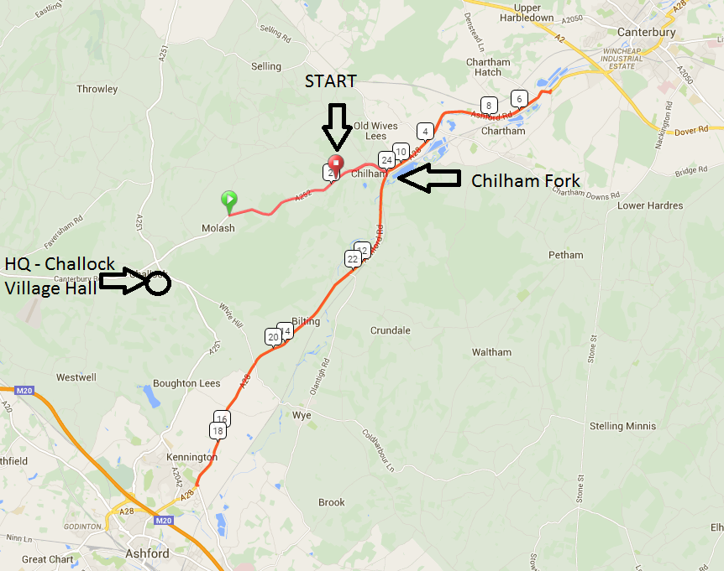

COURSE DETAILS for Q25/8:

START on A252 East of Molash at corner post of Northdown House at entrance to Shottenden Lane. (TR032521) Proceed east on A252 and A28 to Milton Manor RAB Thanington (6.726 miles). TURN and retrace on A28 via Chilham fork where bear (EXTREME CARE) left to Spearpoint Corner RAB (17.126 miles). Retrace to Chilham fork where left to rejoin A252. Proceed westwards to FINISH approx 290 yards past Chilham Castle Keep entrance (TQ063535).

WARNING : EXTREME CARE when descending the A252 (Molash) Very rough road surface with potholes.

<https://app.strava.com/segments/4499522>

<http://www.mapmyride.com/so/ceeldheer-galguduud/q25-8-route-2424545>

<http://www.bikely.com/maps/bike-path/Q25-8>

<http://ridewithgps.com/trips/29926>

|  |
| --- |
| **Sponsored Clubs**  4T+ Velo Club - Genco/N. Dibble Felt Roofing  All Terrain Cycles  Ashford Tri Club  Abellio SFA RT - Abellio  Arctic-Tacx RT – artic-aircon.ltd.uk  Banks/Catford CC Equipe  Kassei CC TeknoFuel  Kingsnorth International Whs  Panagua.CC  PMR@Toachim House - Toachim House  SigmaSport.co.uk – SigmaSport-co.uk  VC Deal - George Hammond Dover/Nico Lapage/Harry Rowland Wheels/Science in Sport  VC Elan - Harry Perry Cycles  Velorefined/Aerosmiths |